Breed Health and
Conservation Plan

Miniature Schnauzer

BHCP/Version 1/Feb 2021

CONTENTS

INTRODUCTION 3
DEMOGRAPHICS 3
BREED HEALTH CO-ORDINATOR ANNUAL HEALTH REPORT 4
BREED CLUB HEALTH ACTIVITIES 5
BREED SPECIFIC HEALTH SURVEYS 5
LITERATURE REVIEW 7
BREED WATCH 12
ASSURED BREEDER SCHEME 13
DNA TEST RESULTS 13
CANINE HEALTH SCHEME RESULTS 14
REPORTED CAESEAREAN SECTIONS 18
GENETIC DIVERSITY MEASURES 19
CURRENT RESEARCH PROJECTS 21
PRIORITIES 22
ACTION PLAN 23
REFERENCES 24

INTRODUCTION

The Kennel Club launched a new resource for breed clubs and individual breeders – the Breed Health and Conservation Plans (BHCP) project – in September 2016. The purpose of the project is to ensure that all health concerns for a breed are identified through evidence-based criteria, and that breeders are provided with useful information and resources to support them in making balanced breeding decisions that make health a priority.
The Breed Health and Conservation Plans take a complete view of breed health with consideration to the following issues: known inherited conditions, complex conditions (i.e. those involving many genes and environmental effects such as nutrition or exercise levels, for example hip dysplasia), conformational concerns and population genetics.
Sources of evidence and data have been collated into an evidence base which gives clear indications of the most significant health conditions in each breed, in terms of prevalence and impact. Once the evidence base document has been produced it is discussed with the relevant Breed Health Co-ordinator and breed health committee or representatives if applicable. Priorities are agreed based on this data and incorporated into a list of actions between the Kennel Club and the breed to tackle these health concerns. These actions and then monitored and reviewed on a regular basis.

DEMOGRAPHICS

The number Miniature Schnauzer registered by year of birth between 1980 and 2019 are shown in Figure 1. The trend of registrations over year of birth (1980-2019) was +150.9 per year (with a 95% confidence interval of +136.0 to +165.9) reflecting the rise in the breed’s population during this time. This is shown in Figure 1, whereby the breed registrations reached a peak in 2011 of 5,946, and have remained at a similar level since, with 5,055 registered in 2019.
It is worth noting that the 1980 registrations figure appears depressed for all breeds due to registrations moving across to the electronic system from paper files.
[A ‘95% confidence interval’ (C.I.) is a tool used in statistics which shows that we are 95% certain that an estimated number is between the lowest number and the highest number provided, the more data available to support this value will reduce the range over which the CI spans].

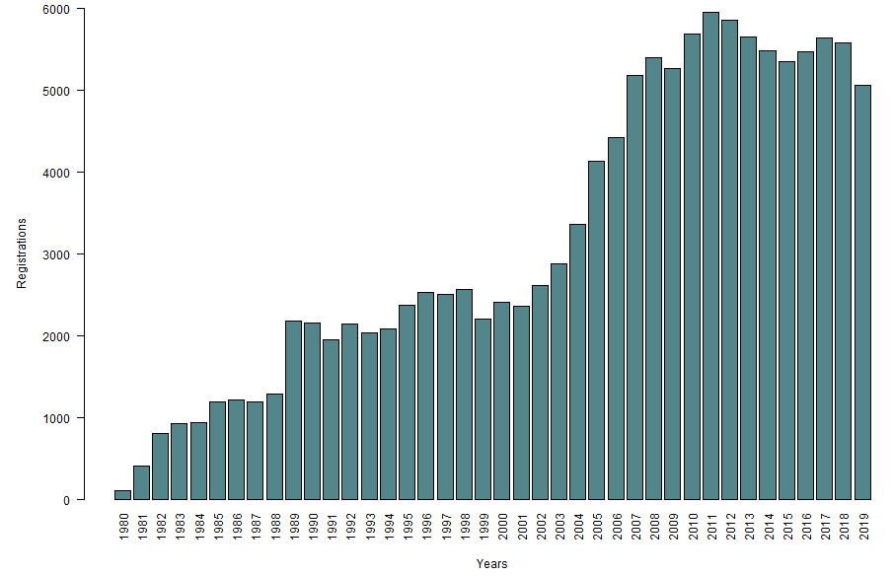
Figure 1: Number of registrations of Miniature Schnauzers per year of birth, 1980 - 2019

BREED HEALTH CO-ORDINATOR ANNUAL HEALTH REPORT

Breed Health Co-ordinators (BHCs) are volunteers nominated by their breed to act as a vital conduit between the Kennel Club and the breed clubs with all matters relating to health.
The Breed Health Coordinators’ Annual Health Report 2019 yielded the following top health concerns:
- Hereditary eye conditions
- Mycobacterium avium complex (MAC)
- Cancers

In terms of what the breed have done to tackle these health concerns, the breed have been working with the Animal Health Trust (AHT) to collect swabs of affected dogs in the aim of producing a DNA test, with the aim of leading to DNA tests for known eye conditions. Similarly, the breed requested that the MAC test be added as an ABS requirement and continues to promote and encourage testing amongst breeders. As well as this, the breed have been updating the Schnauzer Breeds Health Survey to improve data collection for cancers and other conditions affecting the breed.

BREED CLUB HEALTH ACTIVITIES

The breed does not currently have a breed council or health sub-committee but has comprehensive health information on the following health pages, specific to Miniature Schnauzers:
- http://www.theminiatureschnauzerclub.co.uk/health/health_info/.
- http://northernschnauzerclub.co.uk/health/size-specific-health/mini-health/
The breed also work closely together across all three varieties, and have formed a health group, with information on health concerns in the varieties here: www.schnauzerclub.co.uk/health.php

BREED SPECIFIC HEALTH SURVEYS

Kennel Club Purebred and Pedigree Dog Health Surveys Results
The Kennel Club Purebred and Pedigree Dog Health Surveys were launched in 2004 and 2014 respectively for all of the recognised breeds at the time, to establish conditions found in the Miniature Schnauzer, and those found in all pedigree dogs. It is important to consider however the small number of dogs used for both mortality analyses.
2004 Morbidity results: Health information was reported for 584 live Miniature Schnauzers of which 393 (67%) were healthy and 193 (33%) had at least one reported health condition. Of the 193 dogs reported to have at least one condition, a total of 388 incidents of conditions were reported. The most frequently reported specific conditions were skin irritation/ itchy skin (3.3% of 584 total dogs, 19 reports), lipoma (2.9% of total dogs, 17 reports), heart murmur (2.9%, 17 reports), and retained puppy teeth (2.1%, 12 reports).
2004 Mortality results: A total of 214 Miniature Schnauzer deaths were reported. The median age of death was 12 years and 1 month (min = 7 months, max = 18 years and 2 months). The most specific causes of death were old age (9.8%, 21 deaths out of 214 deaths), heart failure (7.9%, 17 deaths), liver cancer (4.2%, 9 deaths), and stroke (3.7%, 8 deaths).
2014 Morbidity results: Health information was reported for 1,019 live Miniature Schnauzers of which 707 (69.4%) reported no conditions and 312 (30.6%) had at least one reported health condition. Of the 312 dogs reported to have at least one condition, a total of 550 incidents of conditions were reported. The most frequently reported specific conditions were lipoma (4.5% of 1,019 total dogs, 46 reports), pancreatitis (3.3% of total dogs, 34 reports), skin (cutaneous) cyst (3.0%, 31 reports), umbilical hernia (1.9%, 19 reports), and dermatitis (1.7%, 17 reports).
2014 Mortality results: A total of 78 deaths were reported, with a median longevity 10 years. The most commonly specific reported causes of death for the breed were old age (12.8%, 10 deaths out of 78 deaths), cancer – unspecified (7.7%, 6 deaths), hepatic/ liver tumour (6.4%, 5 deaths), and unknown (6.4%, 5 deaths).

Breed Club Health Surveys
Joint Schnauzer Breeds Health Survey 2013 – 2019
The four UK Schnauzer breed Clubs initiated an ongoing health survey in 2009 covering the three Schnauzer sizes. Data is constantly updated and reported on at frequent intervals.
From the most recent report (2013 – 2019) responses were received from 1,437 owners, which represented 1,945 dogs, 940 dogs and 1,005 bitches. The majority of dogs (1,792) were reported to be free from any disorders/ defects, apart from 192 dogs.
With regard to reported health concerns, the top conditions are summarised in the table below.
Table 1: Summary of Reported Health and Welfare / Behaviour Concerns for Miniature Schnauzer Owners.
Condition | Number Affected
Other | 47
Gastrointestinal | 46
Eye Conditions | 19
Heart Problems | 18
Bladder Problems | 16
Epilepsy | 14
Auto-immune Disease | 11
Hypothyroid | 11
Cancers | 5
Kidney disorder | 4
Spondylitis | 1
Lymphoma | 0

Welfare / Behaviours were also investigated in dogs of the breed, with 281 reported as showing unusual behaviours. The most common reported problems were being noisy (n=125), other (n=76), timidity (n=46), aggressiveness (n=22), being destructive (n=11) and poor house training (n=1).
With regard to mortality data, the breed has recorded 265 deaths for the variety, with the range of death being 0 year 2 months – 17 years 2 months, and a mean age of 10 years 3 months, and median 10 years 11 months. The top five specific causes of death were cancers (n=68), kidney disorder (26), old age (23), liver problems (20) 10and heart problems (19).
The breeds are currently undergoing the fourth joint health survey, with responses being collected on the Schnauzer Health Survey website: http://www.schnauzerhealthsurvey.org.uk/

LITERATURE REVIEW

The literature review lays out the current scientific knowledge relating to the health of the breed. We have attempted to refer primarily to research which has been published in peer-reviewed scientific journals. We have also incorporated literature that includes dogs residing within the UK primarily, to reflect the UK population, but appreciate that it can be useful for breeders and owners to be aware of conditions affecting dogs of the breed internationally. We have also attempted to use literature that was released relatively recently to try to reflect current publications and research relating to the breed.
Mortality: Analysis of the Kennel Club Purebred Dog Health Survey 2004 yielded 289 responses for dogs of the breed (Adams et al, 2010). These responses accounted for 214 Miniature Schnauzer deaths, with a median age of 12.08 years (range 0.58 to 18.17 years). Old age was the most common cause of death, accounting for 23.7% of deaths, followed by cancer (22.3%) and then cardiac (6.6%).
Cancers
General cancers: A paper researching cancer-related deaths in a range of breeds, using data from the 2004 Purebred Dog Health Survey (page 5) did not establish any key cancers as being a concern in the breed (Dobson, 2013). Of 214 deaths for the breed, 46 (21.5%) were due to cancers with a median age at death of 12.08 years.
Dental Conditions
Periodontal disease: Periodontal disease is the most common infectious disease of adult dogs. It is a progressive, cyclical inflammatory disease of the supporting structures of the teeth and is a major cause of dental disease and early tooth loss in dogs and cats. In a study, (Marshall et al, 2014) concluded Miniature Schnauzers present a predisposition for this condition, based on 52 dogs of the breed (bred for research purposes). The authors found that all dogs had teeth at the beginning of the study with some level of gingivitis, with 23 teeth (equating to 12 dogs) having confirmed periodontitis. Over the period of 60 weeks, 35 dogs had at least 12 teeth progress to periodontitis. The rate of periodontitis progressed much more quickly in older dogs. From this, the authors concluded that the disease progresses very quickly in the breed, in comparison to previously studied breeds, and that this breed requires routine oral health care. A larger study of UK based dogs of the breed undertaken by O’Neill et al (2019) refers to this condition and is listed on page 9.
Endocrine/ Hormonal Conditions
Diabetes mellitus (DM): There are several causative factors for diabetes that are understood to date, including immune mediated damage of pancreatic cells, chronic pancreatitis and hormonal interference leading to insulin resistance (Holder et al, 2015). Whilst a US study found the breed to be one of three with the highest risk to develop DM, this has not been replicated in the UK (Davison et al, 2006). However, a study of diabetic dogs samples referred to the Royal Veterinary College found the breed to have a possible predisposition to producing anti-insulin antibodies, due to the presentation of specific dog leukocyte antigen (DLA) genes, which reduce the ability for the body to accept insulin during treatment (Holder et el, 2015).
Musculoskeletal Conditions
Myotonia congenita: Defects in the ability of muscles to transfer electrical or mechanical stimulus led to the development of this condition, characterised by wasted muscles, stiffness, difficulty in getting up after a period of rest, bunny hopping when running, overshot lower jaw, and difficulty breathing or swallowing (Bhaleao et al, 2002). The condition has been proposed as being inherited as an autosomal recessive trait. A total of 372 Miniature Schnauzers were tested over the period of a year, originating from the US, Canada, Australia, and Europe. The research established that the mutant allele (C1C-1) found in carrier or affected dogs was traced to a common carrier ancestor. A DNA test has been made available following the outcomes of this study. The breed recommends that if found, parentage and any actively breeding close relatives should be DNA tested, as a commercial DNA test is available.
Neurological Conditions
Demyelinating polyneuropathy: Abnormally focally folded myelin sheaths were reported in three Miniature Schnauzers in France in 2008, predicted to represent a naturally occurring canina homologue of Charcot-Marie Tooth (CMT) disease. The discovery of additional cases has followed this work and led to a genome-wide association mapping approach to search for the underlying genetic cause of this disease (Granger et al, 2019). Clinical signs include regurgitation in conjunction with megaesophagus and aphonic bark with or without obvious neuromuscular weakness at a young age (under the age of two years). A genetic variant of SBF2 (MTRM13) has been identified as a strong candidate for disease in affected Miniature Schnauzers with this polyneuropathy. The authors proposed an autosomal recessive mode of inheritance and a DNA test has been made available. The breed recommends that if found, parentage and any actively breeding close relatives should be DNA tested, as a commercial DNA test is available.
Ocular Conditions
Hereditary cataracts: There are thought to be two forms of hereditary cataracts that affect the breed – congenital hereditary cataracts (CHC), and hereditary cataracts (HC). Genotyping undertaken by the Animal Health Trust (AHT) on five Miniature Schnauzers (three affected, one carrier, one of unknown status) suggested, at the time, that hereditary cataracts are inherited in an autosomal recessive manner (Mellersh et al, 2006). Since however, it has been hypothesised by the research group that the inheritance of HC may have a more complex inheritance, and further research is needed to confirm this. Further information on ocular conditions affecting the breed is shown on page 17.
Progressive retinal atrophy (PRA): PRA results in loss of vision in affected dogs and has been found to have several different mutations contributing towards disease (Downs et al, 2014). The breed has been reportedly affected by a subset of disease known as PRA-A (or Type 1) and PRA-B (or Type 2). However, prevalence estimates have not been established and whilst DNA tests are available, these require further confirmation to definitively prove any association with disease in the breed. The breed recommends that if found, parentage and any actively breeding close relatives should be DNA tested, as a commercial DNA test is available.
Renal Conditions
Uroliths (kidney stones): This condition is characterised by the formation of uroliths or renal stones, an accumulation of minerals and amino acids due to a defection in re-absorption in the kidneys. Of 14,008 stones submitted to Hill’s Pet Nutrition UK between 1997 and 2006, 435 were from Miniature Schnauzers (Roe et al, 2012). The most common form of stone was made up of struvite, accounting for 213 of the total breed’s sample, followed by oxalate (n=172) and mixed (n=21). From this, the authors established an odds ratio of 6.29 (95% CI 5.26 – 7.55) for struvite stones, 8.27 (95% CI 6.80 – 10.06) for calcium oxalate stones, and 3.11 (95% CI 1.97 – 4.92 for calcium oxalate stones. Whilst the condition is seen in the breed, the authors did not however list the breed as one of the top predisposed breeds.
Reproductive Conditions
Persistent Müllerian Duct Syndrome (PMDS): This condition is due to the failure of the müllerian ducts (tissue which eventually differentiates into fallopian tubes) to regress in the male foetus during development. Approximately 50% of PMDS-affected males have issues with regard to infertility and may be predisposed to testicular tumours (Pujar and Meyers-Wallen, 2009). A mutation in the AMHR2 gene has been identified in the breed as consequential to this condition and found to be inherited in a simple recessive manner with a DNA test widely available. The breed recommends that if found, parentage and any actively breeding close relatives should be DNA tested, as a commercial DNA test is available.
Spondylocostal Dysostosis (Comma Defect/ SCD4): This condition was detailed in a 2015 familial study involving three affected and up to five family members in Australia (Willet et al, 2015). Within the immediate family, the findings supported a highly penetrant autosomal recessive mode of inheritance. The authors identified a mutation in the HES7 gene but noted the low allele frequency in the tested population. This condition is almost entirely presented by stillborn puppies or those that die shortly after birth, with puppies having significant skeletal abnormalities, including a shortened trunk and vertebral malformations. A DNA test is available, and the breed recommends that if found, parentage and any actively breeding close relatives should be DNA tested, as a commercial DNA test is available.

VETCOMPASS
The Kennel Club work closely with VetCompass, a tool that has been developed to collect information from more than 1,100 national veterinary practices, which can be used to identify common breed-specific conditions, or condition-specific concerns which affect a range of breeds. A breed specific VetCompass paper has been undertaken for the breed, with the findings detailed below. Two further condition specific papers undertaken by the VetCompass project are also detailed below.
A total of 455,557 dogs from 304 clinics were included in the study cohort of which 1,972 Miniature Schnauzers were incorporated into the study (O’Neill et al, 2019). The average lifespan for the breed was 11.6 years (range 0.5 – 17.0 years). The most commonly reported health conditions seen in the breed are shown in Table 1 below.
Table 1: Prevalence of the most common disorders at a fine-level of diagnostic precision recorded in Miniature Schnauzers (n=1,972) attending UK primary-care veterinary practices participating in the VetCompass programme during 2013.
Condition | Count (%) | Female prevalence | Male prevalence
Periodontal disease | 343 (17.4%) | 19.6% | 15.4%
Obesity/ overweight | 164 (8.3%) | 10.2% | 6.4%
Anal sac impaction | 114 (5.8%) | 5.2% | 6.4%
Vomiting | 100 (5.1%) | 4.8% | 5.4%
Otitis externa | 99 (5.0%) | 5.2% | 4.9%
Ear disorder | 97 (4.9%) | 4.4% | 5.5%
Heart murmur | 82 (4.2%) | 5.5% | 2.9%
Diarrhoea | 68 (3.4%) | 2.3% | 4.6%
Skin mass | 63 (3.2%) | 2.8% | 3.7%
Undesirable behaviour | 52 (2.6%) | 2.7% | 2.6%

The most common grouped disorder by system was dental (19.2% prevalence), enteropathy (13.7%), skin (12.7%), aural (10.0%) and obesity (8.2%). Periodontal disease and obesity/ overweight were at a similar rate than those seen in other similar sized breeds investigated through VetCompass, with the rates of anal sac impaction, and otitis externa slightly below the all-breed prevalence. From this, the authors highlighted the importance in raising appropriate husbandry with owners of this breed to avoid such welfare concerns.
Whilst the study found the breed did not have a significant predisposition to periodontal disease, the high prevalence still marks out periodontal disease as an important disease to the breed. It is possible that only the more severely affected subset of dogs was identified and diagnosed during general veterinary examinations and that the true prevalence of periodontal disease may be higher still.
The most common causes of death were neoplasia/ cancers (14.7%, 11 dogs), collapse (13.3%, 10 dogs), mass-associated disorder (10.7%, eight dogs) and brain disorder (10.7%, eight dogs) – however, this was based on only 75 reported deaths of the breed, which is considered a small sample size. The authors noted that the breed had a similar probability of death from these particular conditions when compared with the general dog population, apart from collapse which appeared to be slightly elevated, but suggested a larger study would be needed before drawing any significant conclusions.
The two condition specific papers undertaken by the VetCompass team are highlighted below:
Cancer
Lipoma: A condition-specific VetCompass paper was undertaken across a number of different breeds, with the Miniature Schnauzer appearing to be at a slightly increased odds of developing lipomas, with an odds ratio of 1.52 (95% CI 1.07 – 2.18, p = 0.021), based on 33 cases out of 3,261 dogs of the breed (O’Neill et al, 2018).
Cardiovascular Conditions
Degenerative Mitral Valve Disease (DMVD)/ Heart Murmurs: Another condition specific VetCompass study looked at the predisposition of different breeds to DMVD and/ or heart murmurs. The Miniature Schnauzer was established as being at an increased risk of risk factors that lead to mitral valve disease when compared with crossbred dogs, with an odds ratio of 2.27 (95% CI 0.86 – 5.95) (Mattin et al, 2015). Similarly, the breed was found to be at an increased odd for heart murmurs, with an odds ratio of 2.15 (95% CI 1.54 – 3.01). This was however based on 5 cases and a total of 714 non-cases for the breed so should be interpreted with caution. The authors noted that the breed had significantly increased odds of being a heart murmur case, but not of being diagnosed with DMVD. This could be due to the relatively few numbers of cases of DMVD which reduced the ability to accurately confirm associations between the two conditions.

INSURANCE DATA
UK Agria data
There are some important limitations to consider for insurance data:
- Accuracy of diagnosis varies between disorders depending on the ease of clinical diagnosis, clinical acumen of the veterinarian and facilities available at the veterinary practice.
- Younger animals tend to be overrepresented in the UK insured population.
- Only clinical events that are not excluded and where the cost exceeds the deductible excess are included.
However, insurance databases are too useful a resource to ignore as they fill certain gaps left by other types of research; in particular they can highlight common, expensive and severe conditions, especially in breeds of small population sizes, that may not be evident from teaching hospital caseloads.
Insurance data were available for Miniature Schnauzers insured with Agria UK. Full policies are available to dogs of any age. Free policies are available to breeders of Kennel Club registered puppies and cover starts from the time the puppy is collected by the new owner; cover under free policies lasts for five weeks from this time. ‘Exposures’ are equivalent to one full policy year; in 2017 (June 2016 – July 2017) there were 3,620 free exposures, 2,525 full exposures and 2,430 claims, in 2018 (July 2017 – June 2018) these figures were 3,635, 2,466 and 2,609 respectively.
It is possible that one dog could have more than one settlement for a condition within the 12-month period shown.
Conditions by number of settlements, for authorised claims (it should be noted that the total number of settlements will be less than the number of claims) where treatments started between July 2017 and June 2018, are shown in Table 2 below.
Table 2: Top 10 conditions and number of settlements for each condition between 1st July 2017 and 31st June 2018 for Miniature Schnauzers insured on full policies with Agria UK
Condition | Number of settlements
Diabetes mellitus | 170
Gastroenteritis | 79
Pancreatitis – acute | 73
Hyperadrenocorticism - adrenal-dependent ("Cushing's") | 69
Hepatopathy (liver disorder) | 63
Lameness finding | 59
Haemorrhagic gastroenteritis | 57
Vomiting - presumed self-limiting | 54
Cataract (unspecified) | 20
Cruciate ligament rupture - caudal and cranial | 14

BREED WATCH

The Miniature Schnauzer is a category 1 breed; therefore, it is not currently mandatory for judges to submit a health monitoring form when judging this breed at championship certificate level. No optional health reports have been received for the breed.

ASSURED BREEDER SCHEME

Currently within the Kennel Club (KC)’s Assured Breeders Scheme it is required that all breeding stock undergo the following prior to breeding:
- Annual eye testing under the British Veterinary Association (BVA)/KC/ International Sheepdog Society (ISDS) Eye Scheme
- DNA test – MAC
It is also recommended that:
- Litters are screened under the BVA/KC/ISDS Eye Scheme

DNA TEST RESULTS

The following DNA test is available for the breed:
- Mycobacterium avium complex (MAC)
A list of laboratories that provide the test can be found through clicking here: https://www.thekennelclub.org.uk/worldwide-dna-tests/

Other DNA tests available include:

- Myotonia congenita
- Demyelinating Polyneuropathy (Charcot-Marie Tooth (CMT) Disease)
- Progressive Retinal Atrophy (PRA) Type B1 PRA (HIVEP3)
- Persistent Müllerian Duct Syndrome (PMDS)
- Spondylocostal Dysostosis (Comma Defect/ SCD4)

Whilst other DNA tests are available for the breed, results from these will not be accepted by the Kennel Club until the test has been formally recognised; the process involves collaboration between the breed clubs and the Kennel Club in order to validate the test’s accuracy.
As a note, as of January 2022 hereditarily clear status will no longer apply after two generations and dogs will need to be retested to confirm the status of that individual. This is to prevent the possibility of misclassification of status and therefore unintentional breeding of affected puppies. Where parentage is confirmed by DNA profile, the major contributor to erroneous status will be removed. Therefore, a less stringent restriction for HC status is applied where parentage is confirmed by DNA test.
To date (05/01/2020) 745 DNA test certificates have been received by the KC and results shown in Table 3 below. As well as this, 4,753 Miniatures have been recorded as hereditarily clear due to both parents being certified as DNA clear. The results of these test results are shown in Table 3 below.
Table 3: MAC DNA results for Miniature Schnauzers tested to date.
Clear | Carrier | Affected | Hereditary Clear | Total
735 (13.4%) | 10 (0.2%) | 0 | 4,753 (86.4%) | 5,498

The breed also hold DNA test certificate data from other laboratories, and have calculated that with between approximately 775 and 800 tests of UK-resident Miniature Schnauzers (results held by breed clubs and/or published by KC) there are between 28 and 31 known carriers. Carriers therefore represent between 3.5% - 4.0% of all UK dogs DNA tested to date.

CANINE HEALTH SCHEME RESULTS

Participation in the British Veterinary Association/Kennel Club Canine Health Schemes is open to dogs of any breed regardless of whether the scheme comes under an ABS requirement or recommendation.
HIPS
A total of just 13 hip score results have been received for the breed, with a breed median of 16 (range 8 – 67).
ELBOWS
Just three Miniature Schnauzers have been elbow graded to date, of which all three were graded a 0.
EYES
The Miniature Schnauzer is currently on the Known Inherited Ocular Diseases List (KIOD - formally known as Schedule A prior to the 1st January 2020) under the BVA/KC/International Sheep Dog Society (ISDS) Eye Scheme for the following conditions:
- Congenital hereditary cataracts (CHC)
- Progressive retinal atrophy (PRA)
- Hereditary cataracts (HC)
The KIOD lists the known inherited eye conditions in all breeds where there is enough scientific information to show that the condition is inherited in the breed, often including the actual mode of inheritance and in some cases even a DNA test.
To date, 16,281 Miniature Schnauzers have been tested under the BVA/KC/ISDS Scheme, with 99.7% of dogs unaffected, and the remaining 0.05% affected by CHC, 0.06% by PRA and 0.19% HC.
Schedule B has been replaced with sightings reports, which are in place to monitor any emerging or existing eye conditions in the breed. The results of Eye Scheme sightings reports of Miniature Schnauzers which have taken place since 2012 are shown in Table 4 (following page).
The BVA/ KC Eye Panel Working Party will continuously monitor the incidence of current and emerging eye concerns and make regular updates to both KIOD and the sightings reports.

Table 4: Reports on Miniature Schnauzers which have participated in the BVA/KC/ISDS Eye Scheme since 2012.
 | 2012 |  | 2013 |  | 2014 |  | 2015 |  | 2016 |  | 2017 |  | 2018
Condition | 958 As | 713 Ls | 1030 As | 705 Ls | 980 As | 671 Ls | 1047 As | 749 Ls | 1020 As | 734 Ls | 1021 As | 788 Ls | 993 As | 713 Ls
Abnormal pigment deposition |  |  |  |  |  |  |  |  | 1
Anterior cortical cataract |  |  |  |  |  |  |  |  |  |  |  |  | 13
Asteroid hyalosis |  |  |  |  | 1
Central PRA-like lesions |  |  |  |  |  | 1
Chorioretinopathy |  |  |  |  | 1 |  |  |  |  |  | 9
Choroidal hypoplasia |  |  |  |  |  | 1
Congenital hereditary cataract |  |  |  | 2
Corneal lipid deposition | 1 |  | 5 |  | 1 |  |  |  | 3 |  | 4 |  | 1
Corneal opacity |  |  |  |  |  |  |  |  |  | 3
Distichiasis | 29 |  | 44 |  | 9 |  | 16 |  | 29 | 4 | 25 |  | 15
Endothelial opacity |  |  |  |  |  |  |  | 17
Eyelid mass |  |  |  |  | 3
GPRA-like appearance |  |  |  |  | 1 |  |  |  |  |  | 1
Hyaloid remnants |  |  |  |  | 2 |  |  | 28
Keratitis |  |  | 1
Micropapilla | 1 |  |  |  |  | 1
Microphthalmos |  |  |  |  |  |  |  |  |  |  | 3
Micropunctum | 1
Multi-focal retinal dysplasia (MRD) |  |  |  |  |  | 1 |  |  |  | 1
Nuclear cataract | 4 |  | 4 |  | 1 | 5 | 2 | 4 | 3 | 5 | 2 |  | 10
Optic nerve hypoplasia |  |  |  |  | 1 |  |  |  |  |  | 2 |  | 1
Other cataract | 16 |  | 60 |  | 20 | 4 | 17 | 17 | 10
Persistent hyperplastic primary vitreous (PHPV) | 1 |  |  |  | 2 |  | 2 | 14 |  |  | 6
Persistent pupillary membranes (PPM) | 7 |  | 6 |  | 15 | 19 | 2 |  | 5 | 9 | 5 |  | 3 | 1
Pigmentary keratitis |  |  | 1
Post capsular cataract |  |  |  |  |  |  |  |  |  |  | 16 |  | 9
Posterior capsule pigment | 3
Posterior post-subcapsular cataract (PPSC) | 11 |  |  |  | 2 |  | 1 |  | 10 |  | 6 |  | 6
Retinopathy |  |  |  |  |  |  |  |  | 7
Trichiasis |  |  |  |  | 5

The Joint Miniature Schnauzer Eye Fund (JMSEF) was developed as a fundraising group by the three Breed Clubs, and has collaborates closely with the AHT, collecting samples for genome sequencing for CHC. Eye results held by the breed to date are shown in Table 5 below, which includes both non-KC registered dogs and registered dogs.
Table 5: Miniature Schnauzer Eye Results Provided by the JMSEF
Year | Adults Tested | Number affected |  |  | % dogs affected
 |  | HC | GPRA | CHC
2018 | 993 | 2 | 2 |  | 0.40
2017 | 1018 | 2 | 1 |  | 0.29
2016 | 1018 |  | 2 |  | 0.20
2015 | 1040 | 7 |  |  | 0.67
2014 | 973 | 7 |  |  | 0.72
2013 | 1022 | 3 |  |  | 0.20
2012 | 958 | 1 |  |  | 0.26
2011 | 985 | 3 |  | 2 | 0.50

From this, the JMSEF have a mean breed incidence of eye disease in tested dogs at 0.4%.
As well as this, the JMSEF have provided a breakdown of Miniature Schnauzer litters screened for CHC to date, which are given in Table 6.
Table 6: Miniature Schnauzer litters screened to date for CHC.
Year | No. of KC Reg Litters | Litters eye screened | Litters with affected pups | Number of puppies affected | % of litters screened | No. of puppies registered | No. of average pups per litter
2017 | 1056 | 787 | 1 | 1 | 74.5 | 5520 | 5.23
2016 | 1030 | 734 | 3 | 3 | 72.1 | 5437 | 5.01
2015 | 1071 | 748 | 3 | 3 | 69.8 | 5420 | 5.06
2014 | 1053 | 671 | 3 | 3 | 63.7 | 5327 | 5.06
2013 | 1101 | 705 | 3 | 3 | 64.0 | 5584 | 5.07
2012 | 1140 | 713 | 7 | 13 | 62.5 | 5797 | 5.08
2011 | 1205 | 688 | 3 | 6 | 57.0 | 5924 | 4.92
2010 | 1163 | 646 | 5 | 9 | 55.5 | 5651 | 4.86
2009 | 1072 | 515 | 5 | 11 | 48.0 | 5231 | 4.88
2008 | 1114 | n/a | 2 | n/a | n/a | 5333 | 4.79
2007 | 1065 | n/a | 2 | n/a | n/a | 5152 | 4.84
2006 | 908 | n/a | 1 | n/a | n/a | 4396 | 4.87
2005 | 872 | n/a | 1 | n/a | n/a | 4122 | 4.73
2004 | 716 | n/a | 2 | n/a | n/a | 3347 | 4.67

AMERICAN COLLEGE OF VETERINARY OPHTHALMOLOGISTS (AVCO)
Throughout 2015 to 2019, 5,974 Miniature Schnauzers were examined for ocular disorders under AVCO. The resultant prevalence data is shown in Table 7 below, alongside that for previous time periods. Overall, 87.9% (5,254 of 5,974 dogs) of Miniature Schnauzers examined between 2010 and 2018 had normal eyes unaffected by any condition.
However, it is important to note that this data is from dogs in the United States and given that the American KC registered approximately 46,000 litters between 2002 – 2011, this data represents a small percentage of the overall population.
Table 7: ACVO examination results for the Miniature Schnauzer, 1991 - 2019
Disease Category/Name | Percentage of Dogs Affected
 | 1991-2014  (n=27,447) | 2015-2019  (n=5,974)
Eyelids
Distichiasis | 2.1% | 1.7%
Uvea
Persistent pupillary membranes (iris to iris) | 1.6% | 1.6%
Persistent pupillary membranes (lens pigment foci/ no strands) | 0.2% | 1.3%
Lens
Cataract (significant) | 3.2% | 3.8%
Adapted from: https://www.ofa.org/diseases/eye-certification/blue-book

REPORTED CAESEAREAN SECTIONS

When breeders register a litter of puppies, they are asked to indicate whether the litter was delivered (in whole or in part) by caesarean section. In addition, veterinary surgeons are asked to report caesarean sections they perform on Kennel Club registered bitches. The consent of the Kennel Club registered dog owner releases the veterinary surgeon from the professional obligation to maintain confidentiality (vide the Kennel Club General Code of Ethics (2)).
There are some caveats to the associated data:
- It is doubtful that all caesarean sections are reported, so the number reported each year may not represent the true proportion of caesarean sections undertaken in each breed.
- These data do not indicate whether the caesarean sections were emergency or elective.
The number of litters registered per year for the Miniature Schnauzer breed for the past 10 years are shown in Table 8.
Table 8: Number and percentage of litters of Miniature Schnauzers registered per year and number of caesarean sections reported per year, 2009 to 2019.
Year | Number of Litters Registered | Number of C-sections | Percentage of C-sections | Percentage of C-sections out of all KC registered litters (all breeds)
2009 | 1100 | 0 | 0.00% | 0.15%
2010 | 1131 | 7 | 0.62% | 0.35%
2011 | 1219 | 14 | 1.24% | 1.64%
2012 | 1107 | 69 | 6.10% | 8.69%
2013 | 1106 | 67 | 5.92% | 9.96%
2014 | 1063 | 67 | 5.92% | 10.63%
2015 | 1089 | 76 | 6.72% | 11.68%
2016 | 1034 | 66 | 5.84% | 13.89%
2017 | 1070 | 80 | 7.07% | 15.00%
2018 | 1088 | 64 | 5.88% | 17.21%
2019 | 942 | 47 | 4.99% | 15.70%

GENETIC DIVERSITY MEASURES

The effective population size is the number of breeding animals in an idealised, hypothetical population that would be expected to show the same rate of loss of genetic diversity (rate of inbreeding) as the population in question; it can be thought of as the size of the ‘gene pool’ of the breed. In the population analysis undertaken by the Kennel Club in 2015, an estimated effective population size of 170.1 was reported (estimated using the rate of inbreeding over the period 1980-2014).
When the effective population size drops below 100 (inbreeding rate of 0.50% per generation) the rate of loss of genetic diversity in a breed/population increases dramatically (Food & Agriculture Organisation of the United Nations, “Monitoring animal genetic resources and criteria for prioritization of breeds”, 1992).
Annual mean observed inbreeding coefficients (showing loss of genetic diversity) and mean expected inbreeding coefficients (from simulated ‘random mating’) over the period 1980-2014 are shown in Figure 5. The rate of inbreeding for the breed appears to be on the decrease, implying increased awareness of genetic diversity when breeders are considering mates for their dog. The blurring of the expected inbreeding coefficient is a result of insufficient data to give a concise answer, however the true value is expected to fall within this blurred area.
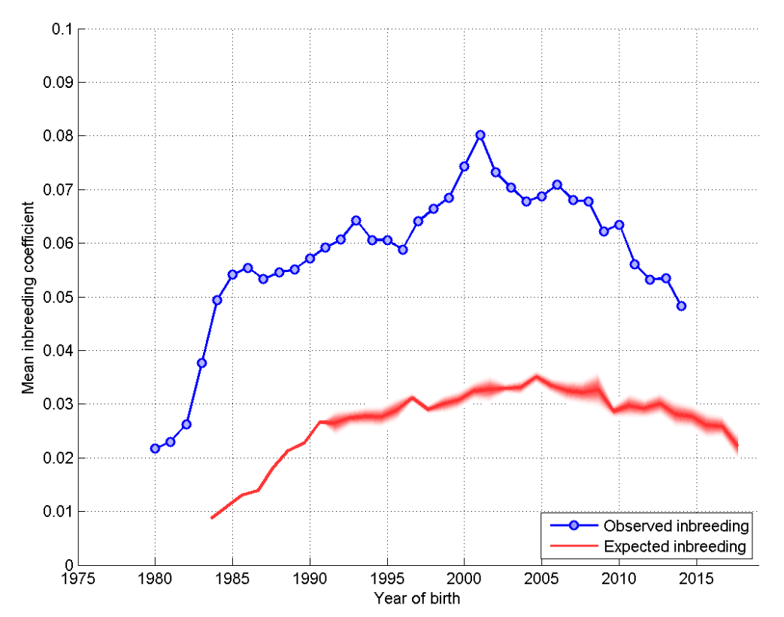Figure 5: Annual mean observed and expected inbreeding coefficients
Below is a histogram (‘tally’ distribution) of number of progeny per sire and dam over each of seven 5-year blocks (Figure 6). A longer ‘tail’ on the distribution of progeny per sire is indicative of ‘popular sires’ (few sires with a very large number of offspring, known to be a major contributor to a high rate of inbreeding).
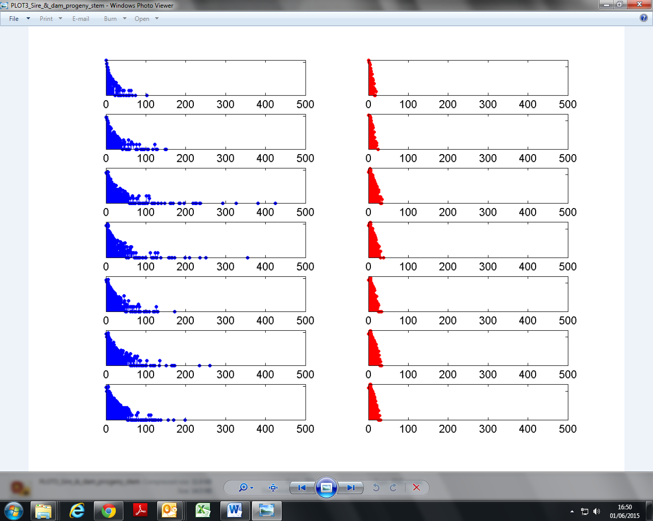
Figure 6: Distribution of progeny per sire (blue) and per dam (red) over 5-year blocks (1980-4 top, 2010-14 bottom). Vertical axis is a logarithmic scale.
1980-1985
1985- 1990
1990- 1995
1995- 2000
2000-2005
2005-2010
2010- 2014

CURRENT RESEARCH PROJECTS

The breed are currently working with the BVA to monitor cases of eye conditions, encouraging owners of affected dogs to submit samples for genome sequencing.

PRIORITIES

A meeting was held with the Miniature Schnauzer breed representatives on 8th March 2020 to discuss the evidence base and priorities for the breed.
The group agreed that the breed priorities for the Miniature Schnauzer would be:
- Hereditary eye conditions
- Mycobacterium avium complex (MAC)
- Cancers
- Periodontal disease
- Welfare / Behavioural issues
- Identify/publicise available DNA tests for conditions known to occur in the breed

ACTION PLAN

Understanding breed health and how to prioritise different disorders is complex, but key to identifying the top priorities is being able to assess all available data and consider an overall picture of the health of a breed. The evidence base above has been developed with this in mind, with the aim to not only assist breeders in improving specific areas of breed health, but also continue to monitor and assess how these change over time. The BHCP will be updated on a regular basis, to ensure this remains relevant and fluid in line with the breed’s health.

With this having been considered, the following actions have been agreed upon, by both the breed clubs and the Kennel Club, to improve the health of the Miniature Schnauzer. Both partners are expected to begin to action these points prior to the next review.

Breed Club actions include:
- The breed clubs to investigate other breed health surveys and methods through which they collect information, specifically with regard to breakdown of cancers, recording of bodyweight, and behaviour

- The breed clubs to investigate how they can improve on advice to owners with regard to dental care

- The breed clubs to consider advice and guidance to assist owners and breeders with regard to behavioural issues in the breed

- The breed clubs to put forward proposals for the recognition of available and applicable DNA tests, to allow for recording of results
Kennel Club actions include:
- The Kennel Club to establish the allele frequency of MAC in the breed

- The Kennel Club to establish the proportion of puppies born that are hereditarily clear

- The Kennel Club and breed clubs to look at categorisation of undesirable behaviours where relevant to welfare and health impact

- The Kennel Club to collaborate with the breed in developing a mortality reporting database, which can be posted on the Breed Information Centre/ breed club websites

- The Kennel Club to repeat the population analysis for the breed

REFERENCES

Adams, V.J., Evans, K.M., Sampson, J., Wood, J.L.N. (2010) Methods and mortality results of a health survey of purebred dogs in the UK. Journal of Small Animal Practice 51: 512-5247
Bhalerao, D.P., Rajpurohit, Y., Vite, C.H., Giger, U. (2002) Detection of a genetic mutation for myotonia congenital among Miniature Schnauzers and identification of a common carrier ancestor. American Journal of Veterinary Research 63(10): 1443-1447
Davison, L.J., Herrtage, M.H., Catchpole, B. (2006) Study of 253 dogs in the United Kingdom with diabetes mellitus. Veterinary Record 156: 467-471
Dobson, J.M. (2013) Breed-predispositions to cancer in pedigree dogs. ISRN Veterinary Science http://dx.doi.org/10.1155/2013/941275
Downs, L.M., Hitti, R., Pregnolato, S., Mellersh, C.S. Genetic screening for PRA-associated mutations in multiple dog breeds show that PRA is heterogeneous within and between breeds. Veterinary Ophthalmology 17(2): 126-130
Granger, N., Feliu-Pascual, A.L., Spicer, C., Ricketts, S., Hitti, R., Forman, O., Hersheson, J., Houldon, H. (2019) Charcot-Marie Tooth type 4B2 demyelinating neuropathy in miniature schnauzer dogs caused by a novel splicing SBF2 (MTMR13) genetic variant: a new spontaneous clinical model. PeerJ 7:e7983 http://doi.org/10.7717/peerj.7983
Holder, A.L., Kennedy, L.J., Ollier, W.E.R., Catchpole, B. (2015) Breed differences in development of anti-insulin antibodies in diabetic dogs and investigation of the role of dog leukocyte antigen (DLA) genes. Veterinary Immunology and Immunopathology 167: 130-138
Marshall, M.D., Wallis, C.V., Milella, L., Colyer, A., Tweedie, A.D., Harris, S. (2014) A longitudinal assessment of periodontal disease in 52 miniature schnauzers. BMC Veterinary Research 10:166
Mattin, M., Boswood, A., Church, D.B., Lopez-Alvarez, J., McGreevy, P.D., O’Neill, D.G., Thomson, P.C., Brodbelt, D.C. (2015) Prevalence of and risk factors for degenerative mitral valve disease in dogs attending primary-care veterinary practices in England. Journal of Veterinary Internal Medicine 29: 847-854
Mellersh, C.S., Pettitt, L., Forman, O.P., Vaudin, M., Barnett, K.C. (2006) Identification of mutations in HSF4 in dogs of three different breeds with hereditary cataracts. Veterinary Ophthalmology 9(5): 369-378
O’Neill, D.G., Butcher, C., Church, D.B, Brodbelt, D.C., Gough, A.G. (2019) Miniature Schnauzers under primary veterinary care in the UK in 2013: demography, mortality and disorders. Canine Genetics and Epidemiology 6:1
Pujar, S., Meyers-Wallen, V.N. (2009) A molecular diagnostic test for Persistent Mullerian Duct Syndrome in Miniature Schnauzer dogs. Sexual Development 3: 326-328
Roe, K., Pratt, A., Lulich, J., Osborne, C., Syme, H.M. (2012) Analysis of 14,008 uroliths from dogs in the UK over a 10-year period. Journal of Small Animal Practice 53: 634-640
Smolders, L.A., Bergknut, N., Grinwis, G.C.M., Hagman, R., Lagerstedt, A-S., Hazewinkel, H.A.W., Tryfonidou, M.A., Meij, B.P. (2013) Intervertebral disc degeneration in the dog. Part 2: chrondrodystrophic and non-chondrodystrophic breeds. The Veterinary Journal 195: 292- 299
Willet, C.E., Makara, M., Reppas, G., Tsoukalas, G., Malik, R., Haase, B., Wade, C.M. (2015) Canine disorder mirrors human disease: exonic deletion in HES7 causes autosomal recessive spondylocostal dysostosis in Miniature Schnauzer dogs. PLOSone https://doi.org/10.1371/journal.pone.0117055

