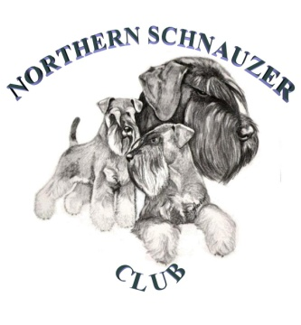
WELCOME TO OUR FUN DAY
Sunday 9th July 2017
At: 10.00am
Where: Eggborough Village
Hall, Doncaster Road
Eggborough,
DN14 0LD

Fun & Games for all the family

- 10.30am Friendship Tests
- 11.30am Child Handling Lessons: Under 10s
10 – 16s
- 12.30pm LUNCH

- 1.45pm AUCTION IN AID OF JMSEF & NSC RESCUE
- 2.30 – 4.30 FUN DOG SHOW & GAMES & FANCY DRESS

- Most Handsome Dog
- Prettiest Bitch
- Waggiest Tail
- Best Walker
- Best 6 Legs
- BEST IN SHOW
- Dog The Judge Would Like To Take Home, BEST IN SHOW Cannot Compete.
- Child Handling: Under 10 Years
10 Years – 16 Years
- Egg & Spoon Race
- ‘7’ Legged Race
- Waiter Race
- Sausage Race
- Sack Race
- Musical Chairs

Throughout the day: NEW ‘Have A Go’, Club Shop, Hints, Tips and
demonstration on Grooming, TOMBOLA

ADMISSION BY TICKET
Members Adults: £5.00, Children (under 10): £3.00
Non-Members Adults: £6.00, Children (under 10): £3.00

For tickets and further details, contact Norma Rylance on 01302 860883 or email: foxwoodgiants@gmail.com

We look forward to seeing old friends once again and meeting new ones.

