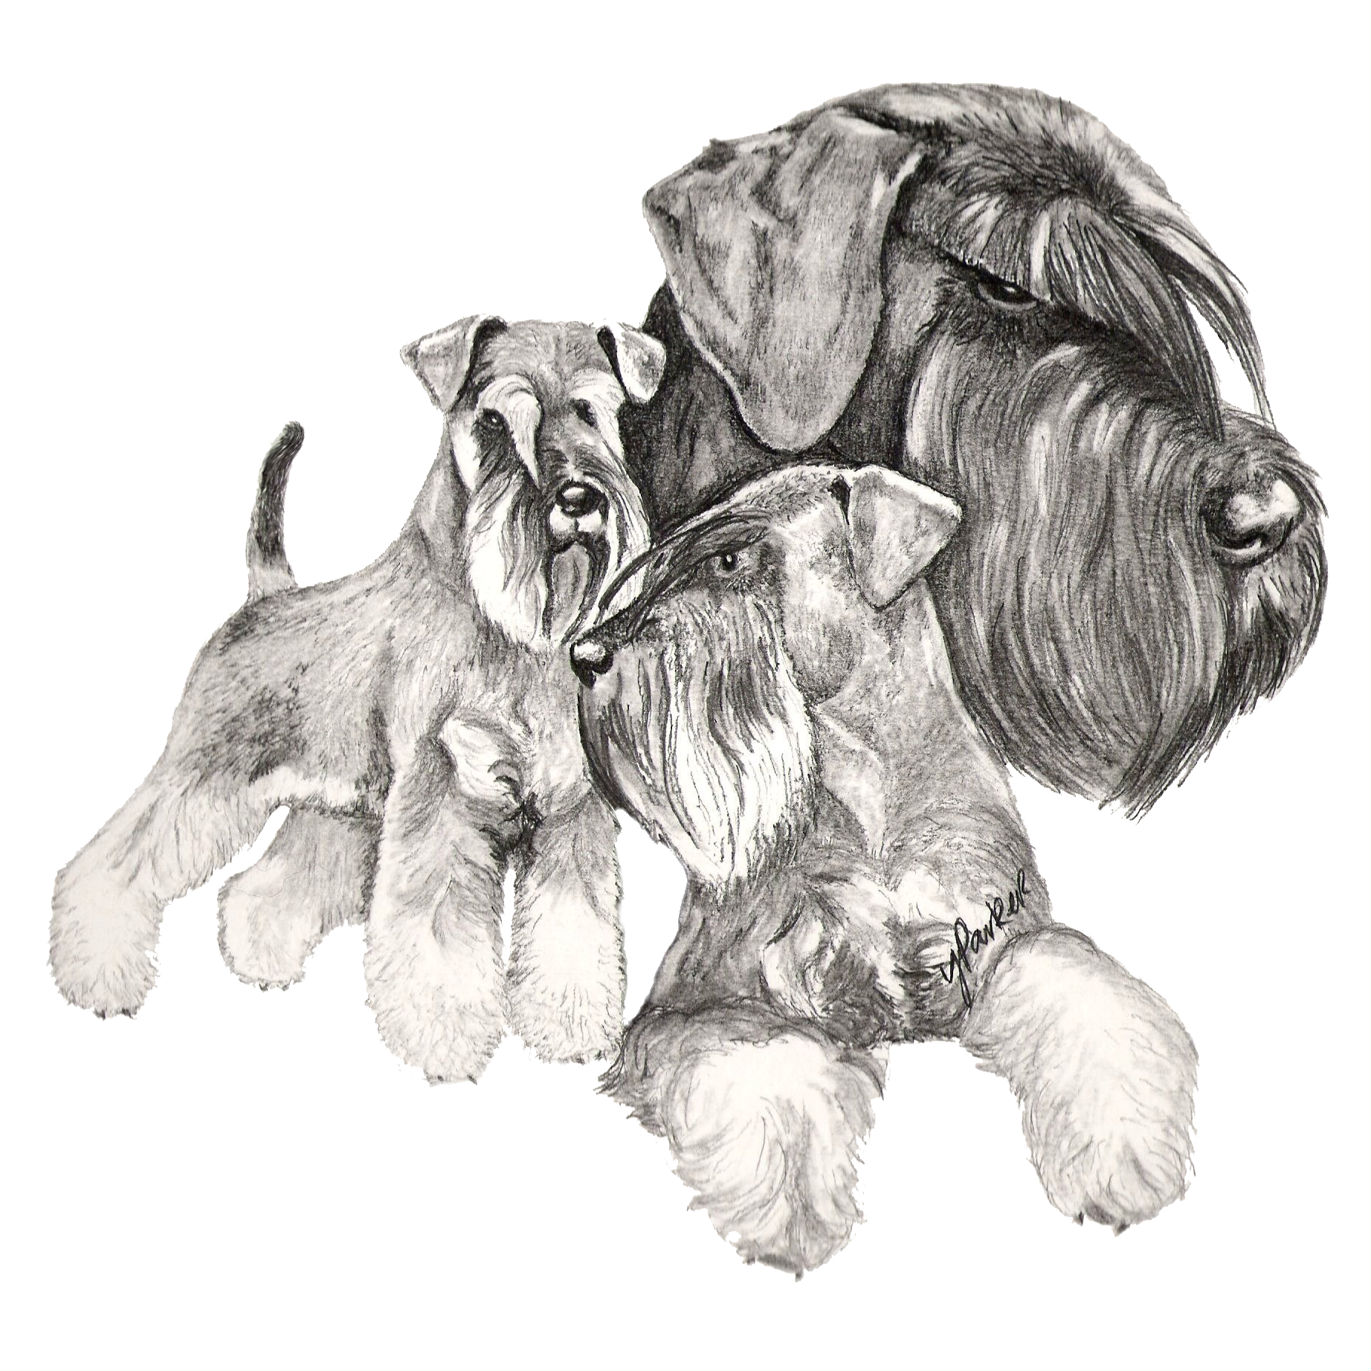
NSC Breed Specific Seminar – Miniature Schnauzer

Sat 14th October 2017, Thorpe Willoughby Village Hall,
Thorpe Willoughby, Selby, YO8 9 BL
9.30-4.00

Breed Specific Seminar: Mr Chris Clay

- Demo of the Breed Standard
- Specific Breed Points
- Opportunity for Hands on Experience (without examination)
- Questions & Answers

Lunch

Assessment

- Hands on Judging Assessment

Cost: Seminar: £15.00 (incl lunch)
Seminar, Multiple Choice Questionnaire & Hands On Judging Assessment: £25.00 (incl lunch)

Details from: Heather Smith - tel: 07809418340
Email: hjsmith111@aol.com

Places will be limited, so please book early

